
March 6, 2015

Specials Next Week:
Monday – P.E.
Tuesday – Library Skills & Art
Wednesday –P.E.
Thursday – Music
Friday –P.E.

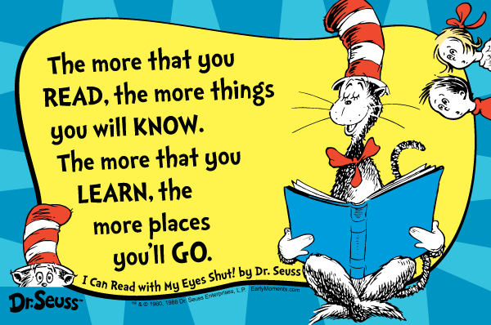

Other Classroom News

☺Spelling Test: Friday, March 6th

**Math and Science quizzes given when students are ready.**

Important Dates:
March 20th – No School (Staff Development)
March 30th- April 6th – Spring Break

April 14th-16th – NYS ELA Test
April 22nd-24th – NYS Math Test

Module 5:
Fractions as Numbers on the Number Line

Topic B: Unit Fractions and Their Relation to the Whole
suffixes –er, -or, -ess, -ist
dentist editor
artist hostess
actress swimmer
seller tutor tourist organist
lioness shipper chemist investor conductor

Earth Science
Volcanoes & Earthquakes

Instructional Focus Module 3, Unit 1
Analyzing Narrative and Supporting Opinions: A Study of Peter Pan
For more information, please go to:
http://www.engageny.org/resource/grade-3-english-language-arts
ELA
MATH

This Week’s Sight Words
Please take the time to make sure your child can read and spell the following sight words.

doesn’t wouldn’t we’re you’re

Thanks for all you do! ☺

